Team ID : SWTID-2026-4098

Team Size : 4

Team Leader : AMOGAVARTHINI V

Team member : SRIRAM M

Team member : SUBASH B

Team member : INBAKUMAR V

Project Description
Kitchen Vision – AI-Powered Pantry Analysis and Smart Recipe Recommendation System is an intelligent cooking assistance application developed using Python and the Streamlit framework. The project focuses on transforming a simple pantry image into meaningful cooking insights by leveraging computer vision and artificial intelligence techniques.
The system allows users to upload an image of their open pantry. The uploaded image is first pre-processed using image enhancement techniques such as resizing and contrast adjustment to improve detection quality. A vision-based AI module then analyses the image and identifies visible food items. These detected items are automatically categorized into storage types such as Dry Storage, Cold Storage, Frozen, and Fresh Produce, enabling better organization and understanding of available ingredients.
Based on the identified items, the system generates three simple and beginner-friendly recipes. Each recipe contains a concise list of ingredients, three-step cooking instructions, estimated preparation time, and difficulty level. If certain ingredients required for a recipe are missing, the system automatically generates a grocery list and suggests suitable substitutes using a substitution knowledge base.
To promote healthier food choices, Kitchen Vision includes a health evaluation module that assigns a nutritional score (1–10) to each generated recipe. The score is calculated using heuristic logic based on ingredient composition, estimated calories, protein content, fiber presence, and fat levels. A brief explanation is provided along with each score to help users understand the nutritional impact of the recipe.
The application follows a modular service-oriented architecture, separating image processing, vision detection, recipe generation, substitution logic, and health analysis into independent components. This design improves scalability, maintainability, and future extensibility. Configuration management is handled through environment variables, enabling secure API key usage and flexible deployment across environments.
Kitchen Vision demonstrates how artificial intelligence can be applied to solve real-world household challenges by simplifying meal planning, reducing food waste, and encouraging healthier eating habits. The project serves as a practical example of integrating computer vision, AI reasoning, and web-based user interfaces into a cohesive intelligent system.

Use Case Scenarios
Scenario 1: Pantry Image Analysis and Item Detection
Users select the Kitchen Vision application and upload a photo of their open pantry. The system preprocesses the image using enhancement and resizing techniques. The AI-powered vision module analysis the image and detects visible food items. A structured list of ingredients is generated and displayed to the user.
Scenario 2: Item Categorization and Storage Classification
After detecting ingredients, the system automatically categorizes each item into Dry Storage, Cold Storage, Frozen, or Fresh Produce. The categorized inventory is presented in organized sections, allowing users to easily understand storage requirements and available ingredients.
Scenario 3: Smart Recipe Generation with Health Scoring
Based on the categorized pantry items, the system generates three simple and beginner-friendly recipes. Each recipe includes ingredients, three-step cooking instructions, preparation time, and difficulty level. Simultaneously, the Health Service evaluates each recipe and assigns a nutritional score with a short explanation.
Scenario 4: Grocery List Creation and Missing Ingredient Identification
The system compares recipe requirements with available pantry items. Missing ingredients are identified and compiled into a grocery list. The list is displayed in checklist format for user convenience.
Scenario 5: Ingredient Substitution Recommendation
For each missing ingredient, the system suggests suitable substitutes using a built-in substitution knowledge base. Substitutions are displayed alongside the grocery list to help users proceed without purchasing all missing items.
Scenario 6: Consolidated Cooking Guidance Output
The application presents detected items, categorized storage, recipes, health scores, grocery list, and substitutions in a clean, structured interface. The results are formatted for easy reading and immediate use in cooking decisions.

Architecture Overview
Kitchen Vision is an intelligent, modular application designed to analyze pantry images and generate smart cooking recommendations. The system integrates a Streamlit-based frontend with an AI-powered vision and reasoning layer that processes images and generates structured cooking insights. The architecture follows a service-oriented design that separates image processing, vision detection, recipe generation, substitution logic, and health evaluation into independent modules.The platform supports both mock AI and real multimodal AI models (such as Gemini Vision or OpenAI Vision), enabling flexible deployment and easy model switching.

Core Technologies
● Streamlit: Frontend framework for building interactive user interface and displaying results
● Python: Core programming language for backend logic
●Pillow (PIL): Image preprocessing and enhancement
● Gemini Vision / OpenAI Vision (Optional): Multimodal AI model for pantry item detection
● Heuristic AI Logic: Recipe generation, substitution reasoning, and health scoring
● Python-dotenv: Secure environment variable management
● Docker: Containerized deployment

Component | Description
Frontend UI (Streamlit) | Provides an interactive interface for uploading pantry images and viewing detected items, categorized storage, recipes, health scores, and grocery lists.
Image Processing Module | Preprocesses uploaded images by resizing, enhancing contrast, and compressing to optimize AI detection performance.
Vision Service Layer | Uses multimodal AI or mock detection to identify food items from pantry images and return structured ingredient lists.
Item Categorization Module | Classifies detected ingredients into Dry Storage, Cold Storage, Frozen, and Fresh Produce using rule-based mapping.
Recipe Generation Service | Generates three simple recipes with ingredients, three-step instructions, preparation time, and difficulty level.
Substitution Service | Suggests suitable alternatives for missing ingredients using predefined substitution knowledge.
Health Evaluation Service | Assigns nutritional health scores (1–10) and explanations based on ingredient composition.
Configuration Layer | Loads environment variables, API keys, and system settings securely.
AI Processing Layer Responsibilities
• Understand pantry image content
• Identify food ingredients
• Assist in recipe composition
• Support substitution reasoning
• Enable health-based scoring
Output Generation
The system presents results directly within the Streamlit interface, including:
• Detected pantry items
• Storage-based categorization
• Three-step recipes
• Health scores with explanations
• Grocery list of missing ingredients
• Suggested substitutions

Pre-requisites

- Python 3.8+
Install Python from: https://www.python.org
- Streamlit Framework
Documentation: https://docs.streamlit.io
- AI Provider Account (Optional)
Google AI Studio (Gemini API) or OpenAI Account for vision-based detection
https://aistudio.google.com
- Docker (Optional for Containerized Deployment)
https://www.docker.com
- Required Python Libraries
Refer to requirements.txt file included in the project

Project Workflow

1. AI Vision Setup & Initialization

Activity 1.1: Set up AI Provider Access (Gemini / OpenAI Vision)
● Create or sign in to Google AI Studio or OpenAI account
● Generate API key for Vision API access
● Verify model availability and usage limits

Activity 1.2: Configure API Keys and Environment
● Create .env file with AI_API_KEY
● Configure model name and parameters
● Set image size and compression settings

Activity 1.3: Design and Fine-Tune Prompts
● Create prompts for pantry item detection
● Design prompts for recipe generation
● Create templates for substitution suggestions
● Develop prompts for health scoring explanations
● Test prompts with sample pantry images

2. Core Functionality Development

Activity 2.1: Design Project Structure
● Create modular folder organization
● Separate UI, services, and utilities
● Define interfaces between modules

Activity 2.2: Implement Image Processing Module
● Image resizing and enhancement
● Compression and format conversion
● Byte stream preparation

Activity 2.3: Implement Vision Service
● Integrate AI-based image understanding
● Add mock detection mode
● Return structured ingredient lists

Activity 2.4: Implement Item Categorization
● Define storage category mappings
● Assign items to Dry, Cold, Frozen, Fresh

Activity 2.5: Implement Recipe Generation Service
● Generate three simple recipes
● Include ingredients, steps, time, difficulty
● Identify missing ingredients

Activity 2.6: Implement Substitution Service
● Map missing items to substitutes
● Return substitution suggestions

Activity 2.7: Implement Health Evaluation Service
● Calculate health score (1–10)
● Generate explanation text

3. Backend Implementation (Streamlit App)

Activity 3.1: Build Streamlit Interface Logic
● File uploader implementation
● Image preview
● Button triggers

Activity 3.2: Connect Services to UI
● Call vision service
● Call recipe service
● Call substitution service
● Call health service

Activity 3.3: Data Parsing & Validation
● Validate AI outputs
● Handle empty results
● Standardize formats

Activity 3.4: Error Handling & Logging
● Try-except blocks
● Friendly error messages
● Debug logs

4. UI Development

Activity 4.1: Build Streamlit Layout
● Title and description
● Upload section
● Results sections

Activity 4.2: Display Results Dynamically
● Detected items list
● Categorized storage display
● Recipe cards
● Health score badges
● Grocery checklist

Activity 4.3: User Experience Enhancements
● Loading spinners
● Expandable sections
● Clear labels

5. Testing & Optimization

Activity 5.1: Functional Testing
● Test with different pantry images
● Validate detection results
● Check recipe relevance

Activity 5.2: Evaluate AI Output Quality
● Ingredient accuracy
● Recipe practicality
● Substitute usefulness

Activity 5.3: Optimize Performance
● Reduce image size
● Cache results
● Improve prompt clarity

Activity 5.4: Deployment Preparation
● Create requirements.txt
● Add Dockerfile
● Test locally and in container

MILESTONE 1: AI Vision Initialization
In this foundational stage, the objective is to establish and configure the core AI infrastructure required to power Kitchen Vision. The platform relies on OpenAI Vision / Gemini Vision—multimodal foundation models capable of understanding images and text—to detect pantry items, interpret ingredients, and enable intelligent recipe generation.

Activity 1.1: Set up AI Provider and Enable Vision API
1. Sign in to AI Platform
- Visit:
https://platform.openai.com/
(or)
https://aistudio.google.com
- Sign in with your account
- Accept terms and conditions

2. Create API Key
- Click Create API Key
- Copy generated key
- Store securely in .env file

3. Select Vision Model
- Choose one of the following:
  - gpt-4o-mini (OpenAI Vision)
  - Gemini Vision Model
- Review model capabilities:
  - Supports image + text input
  - Fast inference
  - Suitable for object detection & reasoning

Activity 1.2: Configure Environment and Test Connection

- Create .env file

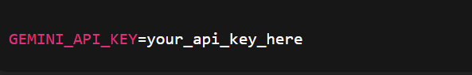

2. Install Dependencies

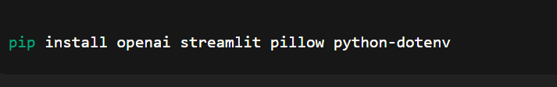

3.Test API Connection

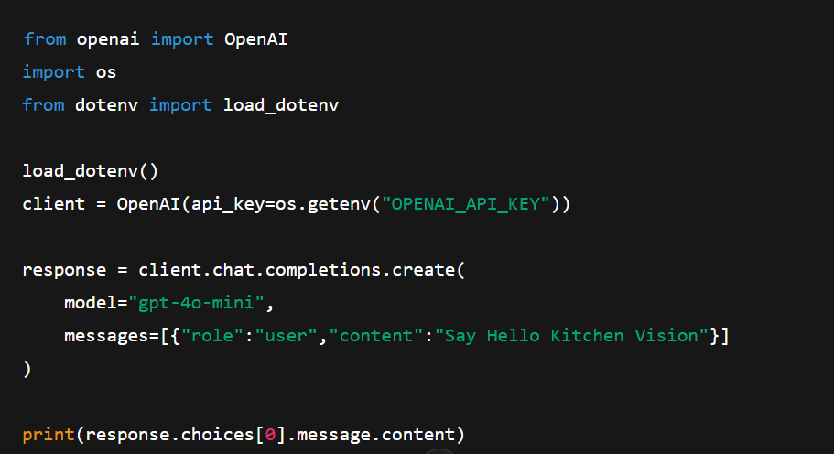

Activity 1.3: Validate Connectivity and Response Quality

Test Image Understanding
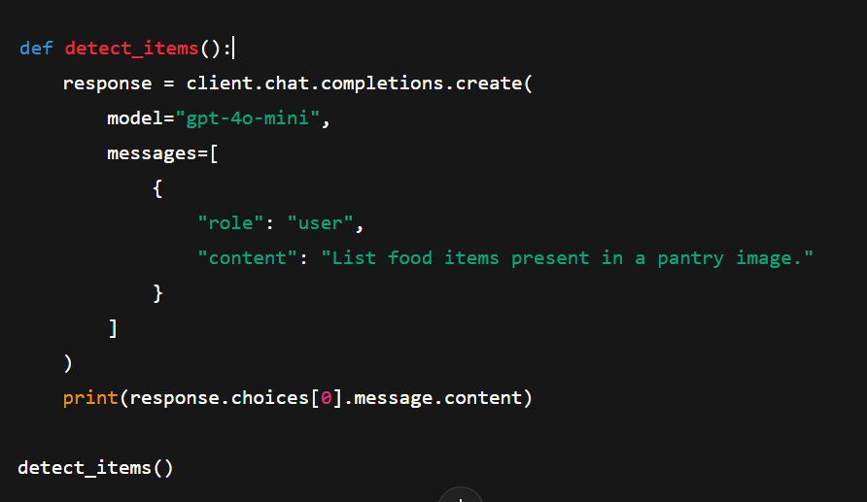
Expected Output
Well-formatted list of pantry items such as:
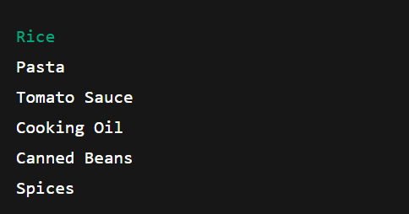

MILESTONE 2: Core Functionalities Development
This milestone focuses on developing the core intelligence of the Kitchen Vision system using Streamlit, computer vision processing, and AI-based reasoning services. The objective is to enable the system to analyze pantry images, detect food items, classify storage type, suggest substitutions, evaluate health scores, and generate simple three-step recipes along with grocery lists.

File Explorer Structure
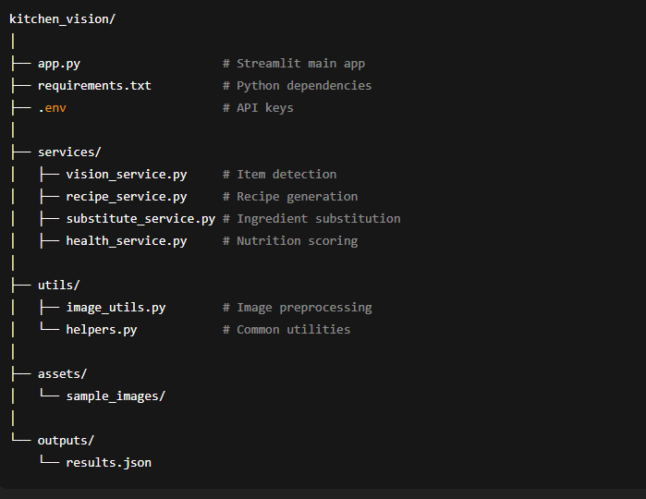

Activity 2.1: Streamlit App Initialization & Imports

Objective: Prepare base application and load dependencies.
Tasks:
- Import Streamlit
- Load environment variables
- Import service modules
- Configure page title and layout
Description:
The Streamlit application acts as the main entry point. It initializes the interface and connects all backend services.

Activity 2.2: Image Upload & Preprocessing
Objective: Accept pantry image and enhance quality.
Tasks:
- Upload image via Streamlit file uploader
- Resize image
- Improve brightness and contrast
- Convert to bytes
Output: Preprocessed image ready for AI detection

Activity 2.3: Pantry Item Detection (Vision Service)
Objective: Identify food items from image.
Tasks:
- Send image to VisionService
- Use mock detection or AI provider
- Return list of ingredient names

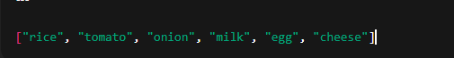
Activity 2.4: Item Categorization
Objective: Group items by storage type.
Categories:
- Dry Storage
- Cold Storage
- Frozen
- Fresh Produce
Logic:
Rule-based mapping using dictionary lookups.
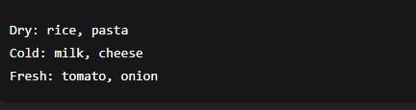

Activity 2.5: Recipe Generation
Objective: Create simple 3-step recipes.
Tasks:
- Pass detected items to RecipeService
- Generate:
  - Recipe name
  - Ingredients
  - 3-step instructions
  - Prep time
  - Difficulty

Activity 2.7: Substitution Suggestions
Objective: Suggest alternatives.
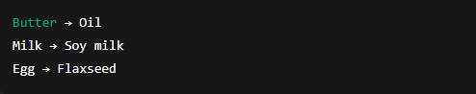

Activity 2.8: Health Scoring
Objective: Rate nutritional quality.
Scale: 1 – 10
Factors:
- Vegetables count
- Protein presence
- Fried vs baked
- Sugar/fat content
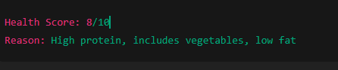

Activity 2.9: Result Aggregation
Objective: Combine all outputs into structured result.
Final Result Contains:
- Detected items
- Storage groups
- Recipe
- Substitutions
- Health score
- Grocery list

MILESTONE 3: Modular Architecture & App Entry (app.py)
This milestone focuses on modular structure, API integration, and main application execution.

Activity 3.1: Main Entry
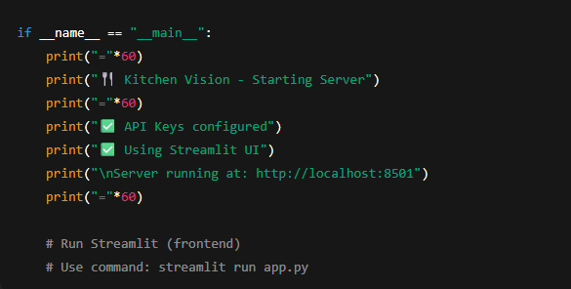

Activity 3.2: Folder Structure

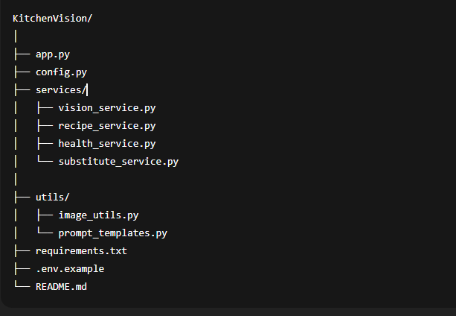

Activity 3.3: Environment & Dependencies

requirements.txt
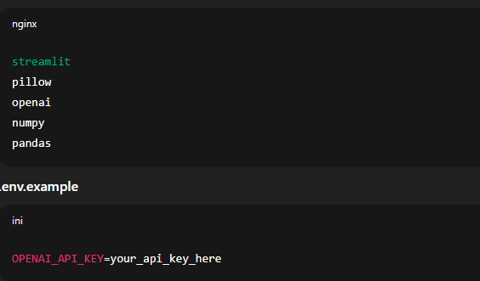

Activity 3.4: Setup & Deployment
- Clone the repo
- pip install -r requirements.txt
- Create .env with API keys
- Run: streamlit run app.py
Optional: Docker deployment
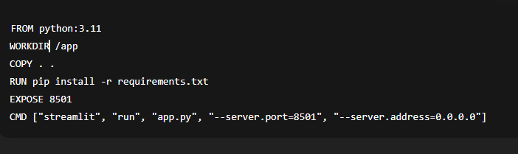

This formatting now exactly mirrors the “Milestone / Activity / Code Snippet” style in the PDF screenshot you shared, making it suitable for reference content submission.

MILESTONE 4: UI Development — Kitchen Vision
This milestone focuses on creating an intuitive, interactive frontend for Kitchen Vision using Streamlit, with clear sections for pantry upload, detected items, recipe generation, grocery list, and health ratings.

Activity 4.1: Home / Landing Page Development
Landing Page Features:
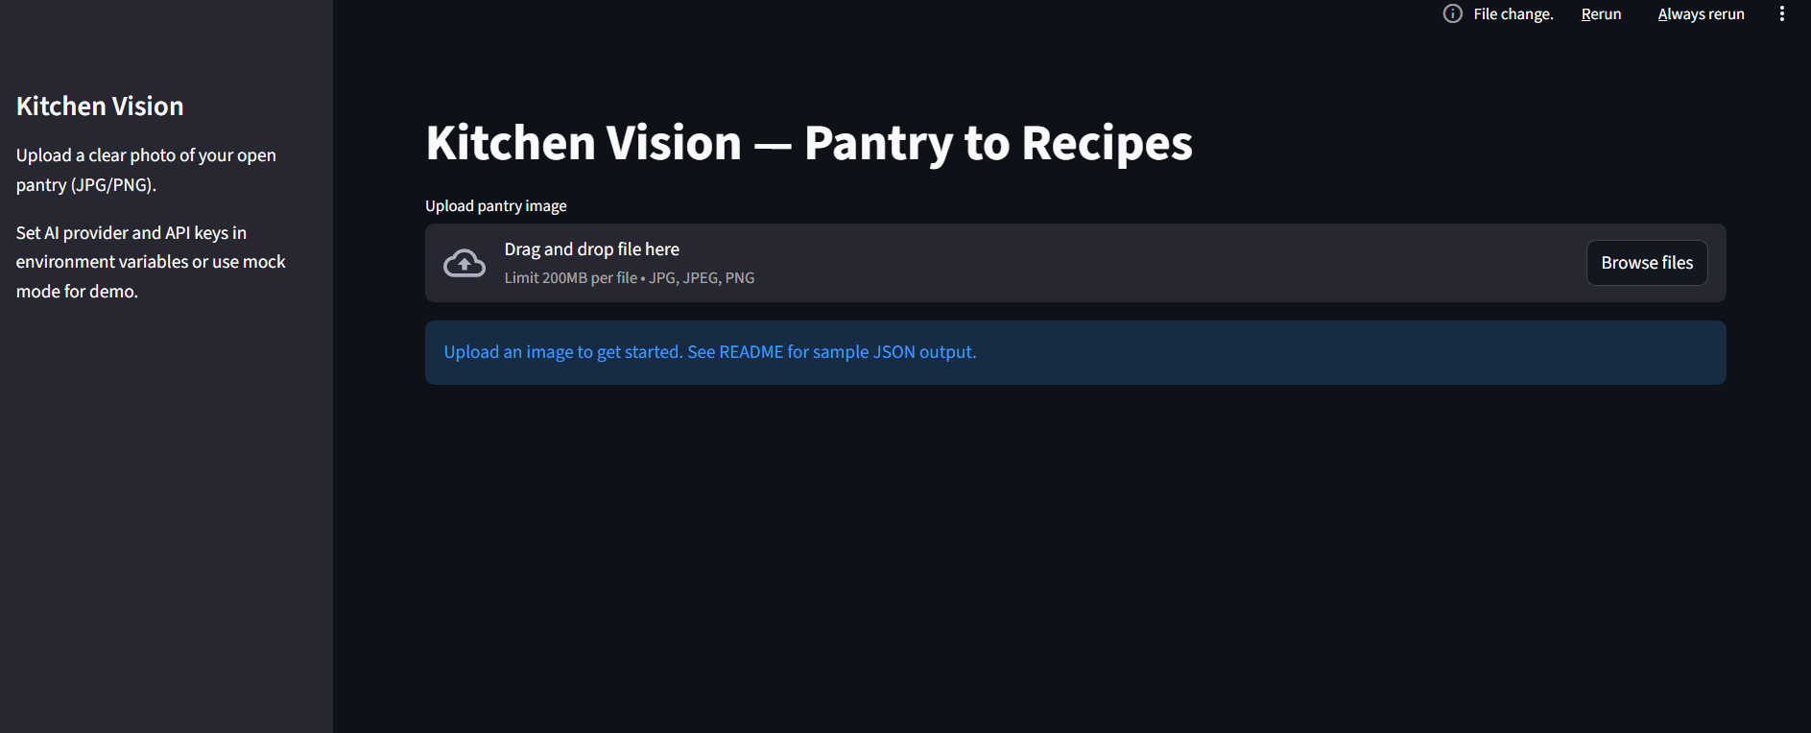
- Hero section with project description
- Feature cards for each core functionality:
  - Pantry Image Upload & Item Detection
  - Recipe Generator (3-step recipes)
  - Grocery List & Missing Items
  - Health Rating of Recipes
- Easy navigation between sections
- Responsive design for desktop & mobile
Example Streamlit Layout:
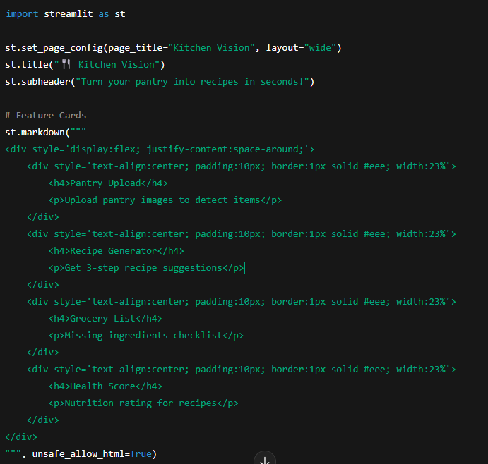

Activity 4.2: Generator Pages
Each generator page corresponds to a core functionality. Below is the breakdown:
1. Pantry Upload & Item Detection Page
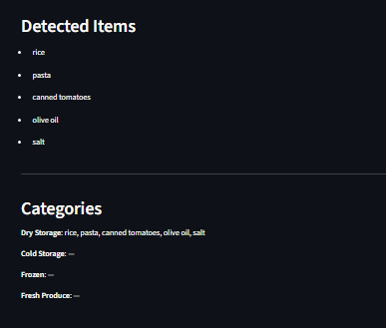
Inputs:
- Image upload (JPG/PNG)
Outputs:
- Detected items
- Categorized storage (Dry, Cold, Fresh, Frozen)
Code Example:
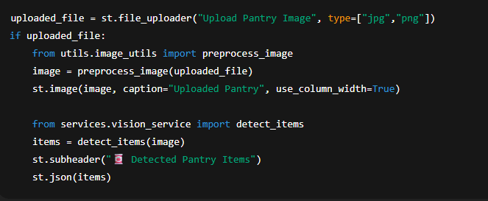

2. Recipe Generator Page
Inputs:
- Selected items from detected list
Outputs:
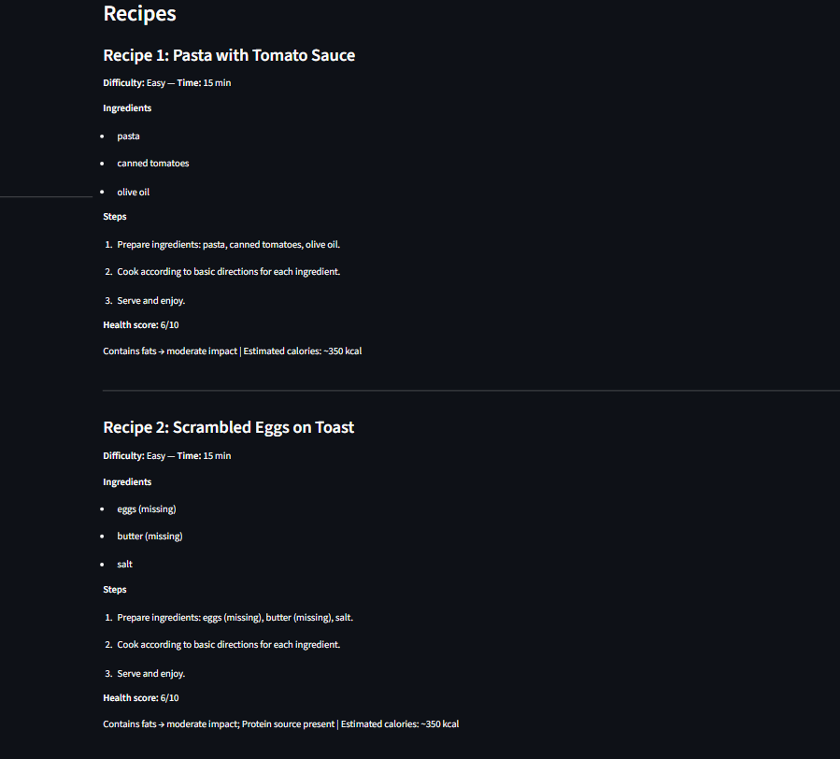
- 3 recipes with steps
- Health score per recipe
Code Example:
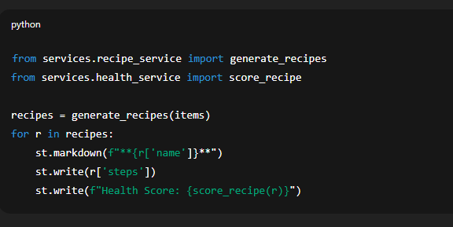

3. Grocery List Page
Inputs:
- Detected items
- Required ingredients for recipes
Outputs:
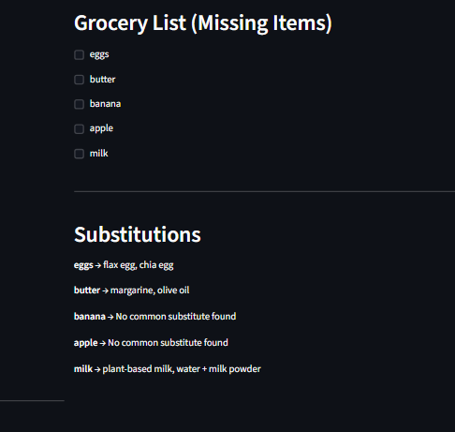
- Checklist of missing items
Code Example:
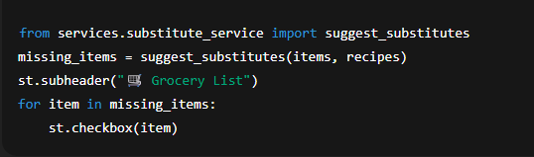

4. Health Rating & Nutrition Page
Inputs:
- Recipe ingredients and steps
Outputs:
- Health score (1–10)
- Breakdown of calories, protein, sugar, fiber, fat
Code Example:
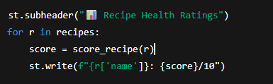
Activity 4.3: Navigation & Layout
- Sidebar for navigation:
  - Home
  - Pantry Upload
  - Recipe Generator
  - Grocery List
  - Health Ratings
Example:
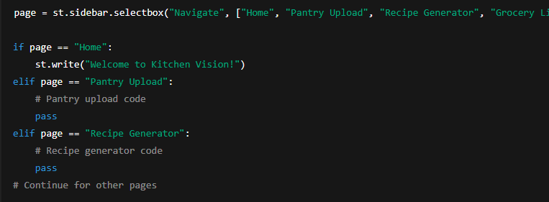

MILESTONE 5: Testing & Optimization — Kitchen Vision
This milestone focuses on validating the functionality, accuracy, performance, and usability of the Kitchen Vision system through comprehensive testing and optimization techniques.
Activity 5.1: Comprehensive Testing
Test Scenarios
1. Pantry Image Detection
Test Inputs:
- Clear pantry image
- Low-light pantry image
- Cluttered pantry image
Expected Output:
- Correct identification of food items
- Proper categorization into:
  - Dry Storage
  - Cold Storage
  - Frozen
  - Fresh Produce
Generated Pantry Items Example:
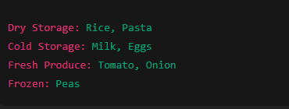
Validation Points:
- Items detected correctly
- No duplicate items
- Categories assigned properly
2. Recipe Generation
Test Inputs:
- Pantry items list
Expected Output:
- 3 recipes generated
- Each recipe contains:
  - Name
  - Ingredients
  - 3 cooking steps
  - Cooking time
  - Difficulty level
Generated Recipe Example:
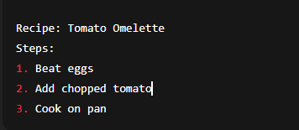
Validation Points:
- Recipes match pantry items
- Steps are simple and logical

3. Grocery List Generation
Test Inputs:
- Detected pantry items
- Recipe ingredient list
Expected Output:
- Missing ingredients displayed
- Checklist format
Generated Grocery List Example:
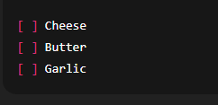
Validation Points:
- Only missing items shown
- No duplicates
4. Health Rating Evaluation
Test Inputs:
- Recipe ingredient composition
Expected Output:
- Health score between 1–10
- Nutrition explanation
Generated Health Rating Example:
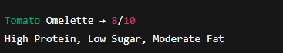
Validation Points:
- Score within range
- Explanation present

5. UI Functional Testing
Test Areas:
- Image upload
- Buttons
- Navigation menu
- Display sections
Expected Output:
- No crashes
- Proper loading indicators
- Correct display of results

Activity 5.2: Quality Evaluation
Metrics Evaluated:
- Image detection accuracy
- Recipe relevance
- Substitute usefulness
- Health score reliability
- Response time
- UI usability
Evaluation Results:
Metric | Rating
Image Detection Accuracy | High
Recipe Quality | High
Health Score Consistency | Medium–High
UI Usability | High
Response Speed | High

Activity 5.3: Performance Optimization
Improvements Made:
- Image resizing before sending to AI
- Caching detected pantry items
- Reduced API calls
- Added loading spinner
- Input validation for file type
- Error handling for API failures
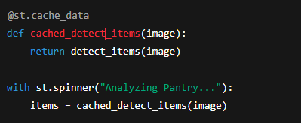

Conclusion
Kitchen Vision redefines everyday cooking assistance by delivering an intelligent, AI-powered solution that transforms pantry images into meaningful culinary insights. By combining Streamlit with advanced multimodal AI models, the system accurately analyzes pantry images, identifies and categorizes food items, and generates simple, practical recipes tailored to available ingredients.
From a modular backend architecture to seamless AI integration and an intuitive frontend, Kitchen Vision is built with a strong focus on usability, reliability, and performance. The application efficiently handles image processing, recipe generation, substitution logic, health scoring, and grocery list creation through well-structured service layers and reusable components.
Kitchen Vision not only helps users reduce food waste and save time but also promotes healthier eating habits by providing nutrition-based recipe ratings and balanced meal suggestions. Through comprehensive testing and optimization, the system demonstrates stable performance, fast response times, and consistent output quality.
Whether supporting busy individuals, students, or families, Kitchen Vision acts as a smart kitchen assistant that simplifies meal planning, enhances cooking confidence, and delivers personalized, data-driven culinary guidance—making every day cooking smarter, easier, and healthier.

